Libspace backend system
Ideation Phase
Define the Problem Statements

Date | 08-03-2026
Team ID | SWTID-2026-3933
Project Name | LIB SPACE
Maximum Marks | 2 Marks

Customer Problem Statement – Libspace Backend System
The Customer Problem Statement helps the development team understand the difficulties users experience when handling book records in a digital environment. By studying these challenges from the user’s point of view, the team can design a backend system that is well-structured, reliable, and secure.
Many small libraries, students, and individual book collectors still maintain their book records manually or through unorganized digital files. The software solutions that are currently available often present several problems, such as:

- Being too complicated for small-scale users

- Requiring paid subscriptions or licenses

- Lacking adequate security measures

- Not supporting user-specific access control

- Being difficult to maintain and manage
Because of these issues, users need a simple and secure backend system that allows them to manage book information effectively while protecting their personal data through proper authentication mechanisms.
Identified User Challenges

During the analysis stage, several key user challenges were identified:

- Absence of secure authentication systems

- No centralized platform for storing and managing book records

- Inability to control or restrict access to user-specific data

- Difficulty modifying or removing existing records

- Possibility of duplicated or inconsistent data entries

Customer Needs

Based on these challenges, users require a system that can:

- Provide secure account registration and login

- Protect user passwords through encryption

- Allow only authorized users to access their data

- Support complete CRUD operations (Create, Read, Update, Delete) for book records

- Maintain a well-organized database structure

- Handle system errors effectively to ensure reliability

Project Focus Based on Customer Needs

To solve these problems, the development team proposed Libspace – Backend Book Management System, which includes the following features:

- Implementation of JWT-based authentication for secure access

- Secure login and logout mechanisms

- Ability for users to create, view, update, and delete book records

- User-specific data separation to maintain privacy

- Development following RESTful API design principles

- Middleware implementation to protect restricted routes

Outcome of the Customer Problem Analysis

- After studying the user problems, the project aims to deliver:

- A secure and reliable backend architecture

- Organized database management

- Well-structured API endpoints

- A scalable backend system

- Practical experience with real-world backend development concepts

The ideation phase ensured that the system is not just technically functional but also aligned with real user problems and practical backend development goals.

Reference: https://miro.com/templates/customer-problem-statement/

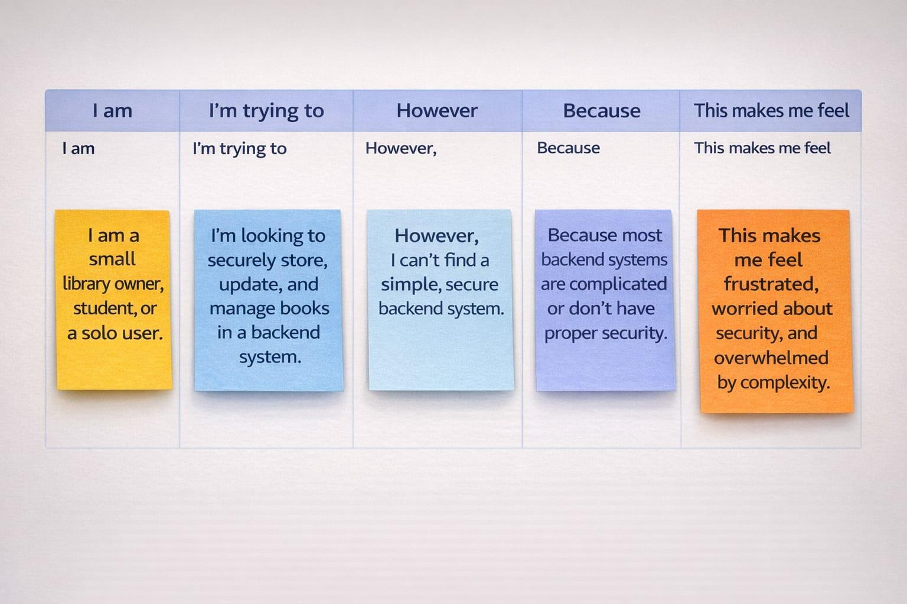

Problem Statement | I am (Customer) | I’m trying to | But | Because | Which makes me feel
PS-1 | A small library owner | Maintain and organize book records using a digital system | Most available tools are complicated or require paid subscriptions | I need a simple backend platform where I can securely add, edit, and remove book details | Stressed about managing records manually
PS-2 | A student who manages personal books | Store and monitor my books in one organized place | There isn’t a secure system that limits access to only my data | I want a login-based platform where only I can control my book records | Worried about the safety of my data
PS-3 | An individual user | Modify and remove book details whenever needed | Many platforms do not offer strong authentication or proper separation of user data | I require a secure backend with JWT authentication and protected API routes | Concerned about unauthorized users accessing my information
PS-4 | A beginner user with limited technical knowledge | Use a simple application to manage books easily | Most systems focus heavily on interface design and not enough on backend security | I prefer a lightweight, secure, and easy-to-use system | Confused and overwhelmed by complicated software

